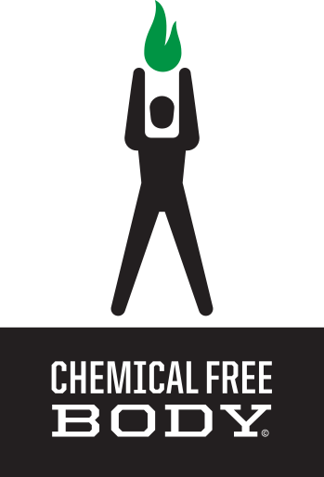

GREEN 85 JUICE FORMULA

Ingredients Profile & Scientific References

By Dr. Scott Treadway

1. Spirulina Amazing source of predigested and complete proteins that regulates blood sugar. Spirulina is also high in iron and calcium. It’s great for women during PMS or anyone with inflammation due to its gamma-linolenic acid (GLA), a powerful anti-inflammatory agent.
2. Chlorella Chlorella is a green algae and is one of the highest sources of predigested and complete proteins. Rich in Vitamins B, C, and E with an array of peptides and polysaccharides. Reduces food cravings and helps to remove heavy metals from the body like mercury.
3. Concentrated Grass Juices Blend (Wheat & Oat) Grasses, the first land based organisms, possess a complete matrix of proteins (in amino-acid form) to build a strong muscular body. They are also rich in Chlorophyll which is very similar to the structure of our own blood. Grasses can neutralize toxins and detoxify us while rejuvenating us on a cellular level.
4. Wheat Sprout: Wheat sprouts are a rare source of a special compound known as Super Oxide Dismutase (SOD), which helps the body to repair itself quickly, slow down the aging process and reduce inflammation. Its also high in folic acid which is great for heart health, brain function, antidepressant activity, and a great detoxifier!
5. Broccoli Sprout: In 1992 researchers at Johns Hopkins doubled broccoli sales overnight when they discovered a phytonutrient called sulforaphane greatly increased the body’s ability to ward off cancer.
6. Moringa Nicknamed worldwide as “The Miracle Tree”, the leaves are nature’s Multi-Vitamin. This is a food plant with powerful antioxidants and multiple health uses along with the ability to suppress appetite and promote weight loss.
7. Acai Berry Pronounced as “ah-sigh-ee”, acai is a reddish-purple berry that grows on the acai palm tree mostly found in Central and South America. The Acai Berry has been consumed by humans for thousands of years. Regular consumption prevents oxidative damage in our body, thus protecting us on a cellular level and keeping us looking young!
8. Dandelion: It is one of the top 6 herbs in the Chinese herbal medicinal tradition and is rich in fiber, potassium, iron, calcium, magnesium, phosphorus and the B vitamins, thiamine and riboflavin, and is a good source of protein. Assists in weight reduction, cleansing the skin and eliminating acne. Purifies blood, cleanses our system, and otherwise improve gastro-intestinal health. Prevents or lowers high blood pressure, lowers cholesterol, and balance blood sugars.
9. Dulse Dulse may be best known for its high iodine content to improve thyroid function but has also been clinically proven to possess free radical scavenging activity, making dulse a useful antioxidant. The seaweed has also been demonstrated to inhibit the growth of fat cells in the laboratory. Utilizing dulse helps to repair compromised body tissues.
10. Concentrated 14 Veggie Juices: A blend of concentrated juices which contain phytonutrients that bulletproof your immune system. A great way to get your servings of veggies that is quick and convenient.
11. Soil-Based Probiotics: Probiotics are the good bacteria in our gut that comprises what should be about three pounds of our immune system. Probiotics help to establish that good bacteria so we can have ideal bowel movements, improved cognitive function, and a stronger constitution. A must in our toxic and high stressed world!
12. Digestive Enzymes: Digestive Enzymes assist the breakdown of food molecules while improving digestion and bowel movements. Neutralizes indigestion with no side bad effects. Digestive Enzymes also carry electric frequency to our cells that literally charges up our battery (our cells) with energy while fighting off free-radical damage keeping us looking young and feeling great.
13. Raspberry Flavor: Cold Pressed raspberry extract loaded with antioxidants to protect us from free-radical damage and absolutely delicious!
14. Monk Fruit: Monk fruit is an awesome sweetener! It is 170 times sweeter than sugar with no downside. It helps to regulate blood sugar, which great for diabetics or pre-diabetics. Also helps reduce food cravings and has no weird aftertaste. Yum!

Join the Chemical Free Movement!
© Copyright 2017
CHEMICAL FREE BODY MEDIA All Rights Reserved.
May be shared with copyright and credit left intact.
www.chemicalfreebody.com

